FORM A1

STUDENT PLAGIARISM DISCLAIMER FORM
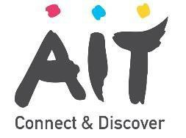

PLAGIARISM DISCLAIMER

STUDENT NAME: Wye Zhen Ng

STUDENT NUMBER: A00290501

PROGRAMME: Bachelor of Science (Honours)
Software Design in Artificial Intelligence for Cloud Computing

YEAR: 2

MODULE: Software Development for Cloud

LECTURER: Declan Byrne

ASSIGNMENT TITLE: Banking Details

DUE DATE: 23 Nov 2022

DATE SUBMITTED: 22 Nov 2022

ADDITIONAL INFORMATION:

I understand that plagiarism is a serious academic offence, and that AIT deals with it according to the AIT Policy on Plagiarism.
I have read and understand the AIT Policy on Plagiarism and I agree to the requirements set out therein in relation to plagiarism and referencing. I confirm that I have referenced and acknowledged properly all sources used in preparation of this assignment. I understand that if I plagiarise, or if I assist others in doing so, that I will be subject to investigation as outlined in the AIT Policy on Plagiarism.
I understand and agree that plagiarism detection software may be used on my assignment. I declare that, except where appropriately referenced, this assignment is entirely my own work based on my personal study/or research. I further declare that I have not engaged the services of another to either assist in, or complete this assignment.

Signed:

Dated: 22 Nov 2022

